

North West Maternal Medicine Network

Clinic Model of Care: Hypertension in Pregnancy

Document Control

Ownership

Name | Role and location | Contact
Natalie Barry | Specialist Maternal Medicine Hypertension Midwife- St Marys Hospital Manchester (GMEC) | Natalie.barry@mft.nhs.uk
Catherine Chmiel | North West Maternal Medicine Network Lead Midwife- North West Region | Catherine.chmiel@nhs.net
Professor Jenny Myers | Professor of Obstetrics and Maternal Medicine/  Consultant Obstetrician | Jenny.myers@mft.nhs.uk

Version control

V0.1 | Circulated to the following groups for comments and feedback:  NWMMN Clinical Reference Group  NWMMN Board | Approved 28/11/24  Approved 05/02/25
V1.0 | Final version | 05/02/25

Contents

The MMN are committed to making maternal medicine care inclusive. We use the term 'women' throughout MMN documentation to refer to those who are planning to become pregnant, are pregnant and have given birth. We acknowledge that not all people who are pregnant and give birth identify as women. It is important that evidence-based care for maternity, perinatal and postnatal health is inclusive and tailored to an individual's wishes.

When referring women, be respectful and aware of all religions, languages, cultures and diversities to ensure best care for all. Please take into consideration the additional challenges faced by those who are from an ethnic minority, have a severe mental illness or are socially deprived as they are at a higher risk of poor physical health and poor outcomes, compared with the general population. The perinatal period adds further complexity, therefore please ensure you consider mental health needs and refer to your local perinatal mental health service appropriately.

Hypertension in Pregnancy North West Maternal Medicine Network

The North West Maternal Medicine Network (NW MMN) is responsible for ensuring that all women in the network’s footprint with significant medical problems will receive timely specialist care and advice before, during, and after pregnancy. All constituent providers within the network will be responsible for agreeing and upholding shared protocols on the management and referral of women with medical conditions, including reviewing guidelines and referral pathways. This model of care will ensure that – where agreed appropriate – investigation and management is carried out by an experienced Multidisciplinary Team (MDT).

Most women with complications during pregnancy will continue to be managed by local maternity services. The proportion of a woman’s care delivered by a Maternal Medicine Centre (MMC) will vary according to individual need. For some women, a single visit to the MMC or communication with the MMC by the local unit will suffice. For the highest risk and most complex women, it may be that all care will be recommended to be delivered within the MMC.

This document aims to assist provider trusts in the Northwest in developing local hypertension services. The goal is to reduce the need for referrals to MMCs by enabling women to receive care closer to home. Benefits of this service include:

- Fewer appointments during pregnancy
- Improved continuity of care
- Reduced pressure on maternity services in triage and antenatal assessment units
- Women supported by an MDT with specialist knowledge in managing hypertension during pregnancy

Introduction and Scope

Antenatal and postnatal services for women with pregnancy hypertension are designed to manage and mitigate the risks associated with high blood pressure during pregnancy. These services encompass a comprehensive range of medical care, including regular monitoring of blood pressure, urine tests for protein, and assessments of fetal well-being through ultrasound scans.

Antenatal care involves dietary and lifestyle counselling, pharmacological management to control blood pressure, and education on recognizing warning signs of complications such as preeclampsia.

Postnatal services extend beyond delivery, ensuring the mother's blood pressure returns to normal and monitoring for any persistent hypertension.

These services also provide support for breastfeeding, postpartum recovery, and mental health, emphasizing the importance of both maternal and neonatal health outcomes. Through these targeted interventions, antenatal and postnatal care aims to reduce the incidence of adverse effects, ensuring a safer pregnancy journey and promoting long-term health for both mother and child.

Purpose

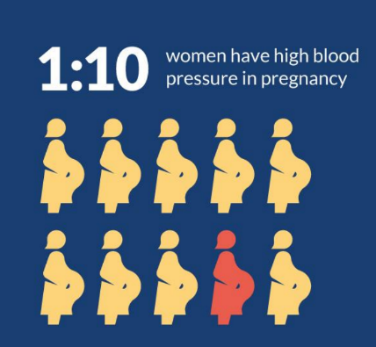
The problem:

Hypertensive disorders of pregnancy are a common medical issue, affecting 10% of all pregnancies. Inconsistent and poorly coordinated care for women with pregnancy hypertension leads to frequent hospital visits, long waiting times and may lead to incorrect management. With the introduction and development of a Specialist Hypertension Clinic optimal outcomes can be achieved where care for pregnant women is guided by a multidisciplinary team with specific expertise in pregnancy hypertension.

Better Births, MBRACE and Ockenden all recommend improving specialist services and MDT working, to enhance the care and safety of complex pregnancies.

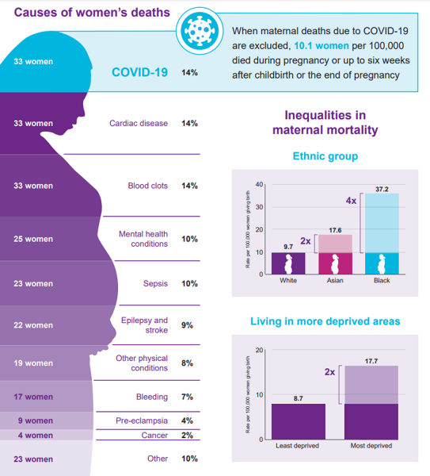
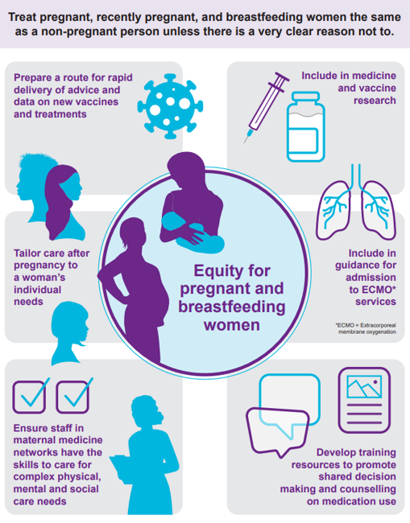

The solution:

To improve care for women with hypertensive disorders in pregnancy by setting up a Specialist Hypertension Clinic

The establishment of a Specialist Hypertension Clinic will provide expert knowledge on hypertension disorders during pregnancy, both antenatally and postnatally. This multi-disciplinary team, comprising of both Doctors and Midwives, will offer access to a staffed phone line available Monday through Friday during working hours. If women have a query out of these hours, they will need to phone their local triage department.
The clinic will ensure that patients follow the appropriate care pathway, as detailed below, and receive optimal hypertension management. This initiative will enhance patient satisfaction, improve continuity of care, and reduce long waiting times.

Suggestions:
- Trust to set up to home BP monitoring app (My GM care, K2 Hampton or equivalent)
- Team ideally should consist of 1-2 Consultant Obstetricians Junior Doctor’s if capacity allows, 1-2 Specialist Midwives

Consider offering pre-conception appointments, in the Specialist Hypertension Clinic, for patients with chronic hypertension who are planning a pregnancy, to review antihypertensive medications in accordance with the NICE recommendations below:

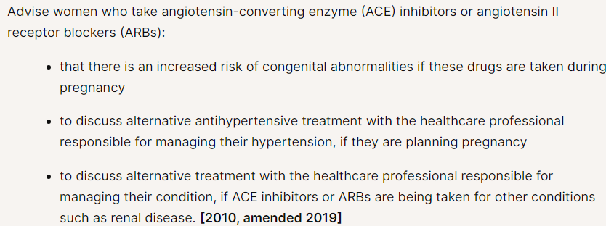

Referrals for pre-con appointments will come via the GP and will depend on the capacity within the Specialist Hypertension Clinic. These appointments can usually be done as phone appointment.

SOP Antenatal Referral Criteria for Specialist Hypertension Clinic

This inclusion criteria for the Specialist Hypertension Clinic is a guide, and can be adapted locally to meet the requirements of each Trust:

- Hypertension at booking: systolic ≥140 and/or diastolic ≥90 and/or diagnosis of hypertension outside of pregnancy
- Current Gestational hypertension (requiring medication)
- Pre-eclampsia in a previous pregnancy under 36 weeks

SOP Antenatal Exclusion Criteria for Specialist Hypertension Clinic

- Previous Gestational Hypertension/pre-eclampsia where birth occurred at term (≥37 weeks) and the baby was ≥10th centile
- Multiple pregnancy as long as being managed in appropriate clinic and has the option of Home BP monitoring
- Any pregnancy with a medical co-morbidity that is prioritised above Hypertension (I.E Diabetes/Cardiac/Renal etc) providing the woman is being managed in an appropriate diabetes/maternal medicine clinic and has the option of Home BP monitoring

Fundamental Principles and Requirements

1.Clinic Space: Operational management/estates

2. Senior Midwife/Obstetric Support: Consider collaborating to optimize learning and development

3. HBPM (optional): funding for pool of BP monitors, monitoring system, access to BP app

4. Clinical Care Pathway: Step by step guide to antenatal care for HDP

5. Clinical Commitment

Step by Step process of Antenatal Care for Hypertension in Pregnancy

- Booking appointment to be completed by the standard process at the provider Trust.

- Nuchal and anomaly scans to be undertaken in the main scan department.

Always working alongside SBL pathway and NICE schedule of appointments (see the following link) NG201 Schedule of antenatal appointments (nice.org.uk)

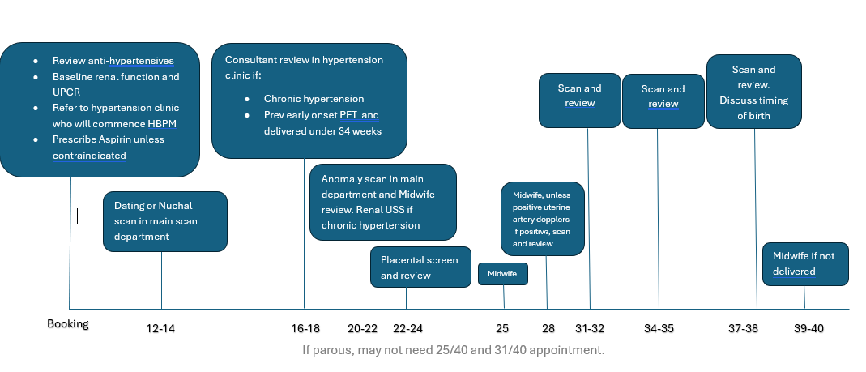
Example schedule of antenatal appointments for the Specialist Hypertension Clinic of a patient booking with chronic hypertension

If multiparous, patient may not need 25-week Midwife appointment.

If your site does uterine artery dopplers (UtAD) at 20 weeks, then the 22-24 week appointment will not ne required, unless any severe concerns at anomaly or any concerns with patient’s BP.

Negative placental screen = End Diastolic Flow (EDF) present and within the normal range EFW =/> 10th centile, normal LV, normal UtAD (PI<95th centile and no uterine artery notches seen)
If the patient has a negative placental screen and:
- Did not develop early onset pre-eclampsia in previous pregnancy
- Does not have chronic hypertension
- Does not currently have gestational hypertension

This patient can be discharged to the SBL scan pathway (below) from 32 weeks, with review in main Antenatal Clinic, and with a referral back to the Specialist Hypertension Clinic if there are concerns regarding BP or an indication that pre-eclampsia is developing/.
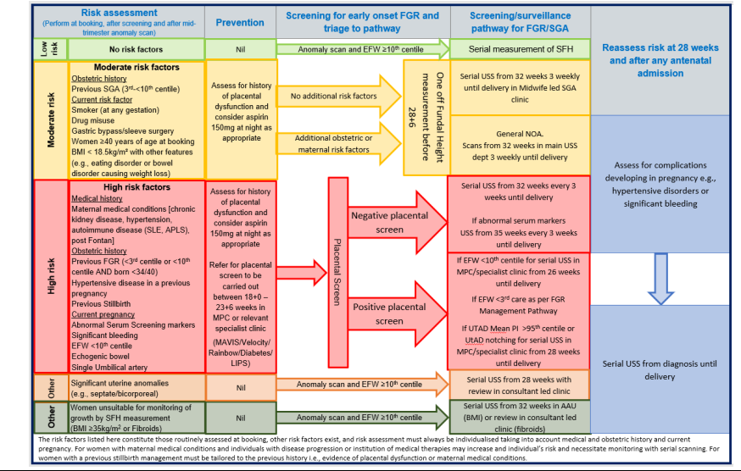

Prescribing & Decision making in Hypertensive Disease in Pregnancy

Women with uncomplicated hypertension (no renal or other end organ disease) should maintain their blood pressure:

Normal BP parameters for all patients on antihypertensive medication, as set by NICE = <135/85
BP treatment should not usually lower BP below 120/70mmHg.
If a patient exceeds their blood pressure target, guidance on anti-hypertensive medication and dosing is provided below, and an antenatal referral should be made to the Specialist Hypertension Clinic, if the patient is not already under this team.

First line antihypertensives:
- Labetalol 200mg tds/qds increasing to a maximum of 600mg qds (contraindication severe asthma)
- Nifedipine MR 10mg twice daily increasing to a maximum 60mg twice daily OR Amlodipine 5-10mg once daily. Where possible increase the primary agent before adding a second therapy to improve compliance

Second line antihypertensives: Women requiring second line antihypertensives require specialist consultant input. The drugs listed below are options provided for reference but should only be commenced following discussion with a specialist consultant obstetrician:
- Doxazosin (2-4mg twice daily)
- Methyldopa (250-750mg TDS)
- Hydralazine (should only be prescribed if all other options have been explored)

Blood pressure should be checked within a week of a change in antihypertensive medication (ideally use home monitoring) with a telephone review with the Specialist Hypertension Clinic.

See Appendix 1 for NIHR antihypertensive therapy resources. These can be given to the patient or laminated on the walls of clinics for clinicians to reference.

Ensure all BP measurements in pregnancy are taken on an automated blood pressure device that is validated for use pregnancy. This is from guidance from NHS England and Saving Babies Lives Version 3. (See sources of support section)

Antenatal Home Blood Pressure Monitoring Advice

Appropriate blood pressure monitoring in pregnancy reduces morbidity and mortality. Home blood pressure monitoring will identify hypertensive disorders of pregnancy earlier, and more accurately, facilitating appropriate treatment.
The physiological changes in pregnancy (increased heart rate, stroke volume and reduced total peripheral resistance) are accounted for in blood pressure devices that a validated for pregnancy. We have included a link to the British Heart Foundation website in our hypertension advice below.

All patients referred to the Specialist Hypertension Clinic should be sent the below or a locally adapted version, via their EPR, or given a printed copy. This will encourage home BP monitoring of at risk patients.

“Following a review of your medical and obstetric history; we would like you to check your blood pressure at home.

We would advise you purchase or borrow an electronic blood pressure monitor to use at home (the following link is useful for for advice on BP monitors - Buy Approved Blood Pressure Monitors I bhf.org.uk;

Please try and check your blood pressure (BP) at least every other day between 9am and 2pm where possible - at least 1 hour after your morning medication (if you have been prescribed medication). We would like you to record these BP readings (e.g. on your phone or in a notebook), so that doctors and midwives can review your readings at your appointments.

If your readings are high (more than 140/90) please contact the specialist clinic XXXXXXXXXX (Mon-Fri 8-4)
If there is no answer, or your call is urgent, then please contact Maternity Triage XXXXXXXX (24 hours; 7 days)”

Level | Blood Pressure (mmHg) | Action
High | SYS 150 OR MORE  OR  DIA 100 OR MORE | Your blood pressure is high  Sit quietly for 5 minutes and measure it again.  Contact the hospital for assessment (within 4 hours) and continue to measure your blood pressure
Raised | SYS 140-149  OR  DIA 90-99 | Your blood pressure is raised  Sit quietly for 5 minutes and measure it again  If your repeated measurement is raised contact your maternity unit within 24 hours and continue to monitor your BP
Normal | SYS 110-139  OR  DIA 70-89 | Your blood pressure is normal  Continue monitoring and your current care
Low | SYS 109 OR LESS  AND  DIA 69 OR LESS | Your blood pressure is low  If you are taking medication for your blood pressure contact your maternity unit within 24 hours or within 4 hours if you feel unwell (dizzy or faint)  If you are NOT taking blood pressure medication your blood pressure does not require any further action.

Neonatal Care

See Appendix 1 to review the neonatal support aid when prescribing antihypertensive medication.

Contraception

Contraception can be discussed at any clinic visit but it is particularly relevant to pre-pregnancy and postnatal consultations. For some women with medical conditions, it is important to discuss the option of sterilisation, if the patient wishes, at the time of Caesarean Section during the pregnancy.

For some women with medical conditions immediate postpartum contraception with either an (intrauterine device) IUD or long-acting reversible contraceptives (LARC) / progesterone implant is appropriate. This option should be discussed during pregnancy.

Contraceptive options should be discussed with women prior to discharge.

Specialist contraception advice may be required for some women. Details for services within each locality can be found in Appendix 2.

Early Postnatal Care

This section aims to implement a streamlined approach to postnatal hypertension management, ensuring patient safety, reducing postnatal admissions, and facilitating appropriate ongoing follow-up within primary care services
Things to consider as the discharging clinician:

- BP target
  - Start if BP >150/100
  - Reduce Rx if BP <130/80

- Antihypertensive choice (use once daily choices where possible)
  - Enalapril (good if likely to need long-term; needs renal function monitoring; ethnicity) 5mg – 40mg OD
  - Nifedipine MR (10mg – 40mg BD) / Amlodipine (5 – 10mg OD)
  - Doxazosin 2-16mg daily usually given twice daily
  - Atenolol (25 – 50mg OD) / labetalol (100mg BD – 600mg QDS)

- Home criteria
  - No symptoms; BP<150/100; bloods stable / improving

- Always consider safety of medications if the patient is breastfeeding.

For all patients that are discharged postnatally on any anti-hypertensive medication, we would advise the following:

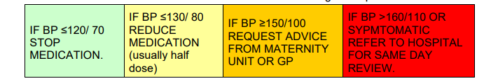

- Upon discharge from hospital, a GP letter should be sent (see overleaf).
- If the patient fits the postnatal referral criteria for the Specialist Hypertension Clinic then a referral should be sent by the ward to the Specialist Hypertension Clinic.
- Blood Pressure should be monitored at least once between day 3-5 postnatal and at least once between day 5-7 if remains hypertensive (≥140/90). If hypertensive, continue to monitor every 2-3 days up to day 14 postnatal. Home BP monitoring can replace community midwife checks after day 5.
- If BP ≥140/90 mmHg current medication should be continued.
- If BP ≥150/100 mmHg (<160/110mmHg) it is usually appropriate to increase the dose of medication or add an additional medication within 72 hours
- Refer to triage for same day review if BP≥160/110mmHg
- If a patient remains on medication at 2 weeks postnatal- a GP review is advised around this time.
- If a patient has discontinued antihypertensive medication, as advised by the pathway overleaf- a GP review is advised at 6-8 weeks.
- See Appendix 3 for an example letter to be sent to the GP for all postnatal patients discharged on anti-hypertensive medication.

Postnatal Clinic

The aim of a postnatal review in the Specialist Hypertension Clinic is to reduce postnatal admissions in relation to hypertension. Hypertension is the most common cause of postnatal admissions, therefore the clinic should be run by a specialist hypertension team. Postnatal services can run alongside the antenatal clinic (i.e postnatal slots at the end of the antenatal clinic) A referral to the Specialist Hypertension Clinic will be completed by the ward, upon discharge from the hospital. Once the referral is received by the Specialist Hypertension Clinic, they will schedule in a PN call, ideally between day 3-5 PN and another call, ideally day 10-14 PN. The clinic aims to improve patient experience and optimise blood pressure control.

Facts:
- BP reduces postpartum then peaks day 3-5 postpartum (hypertensive and normotensive women). PN readmission for poorly managed hypertension is common, normally with the first 2 weeks postpartum. We aim to reduce this by setting up the Specialist Hypertension Clinic.

- Cardiovascular risk is increased with hypertensive disorders of pregnancy.

- It is important to raise awareness/providing education: smoking cessation, healthy lifestyle, maintaining a healthy weight.

Inclusion postnatal criteria for referral to Specialist Hypertension Clinic:
Chronic hypertension on medication
Pre-eclampsia <36 weeks
Gestational hypertension on 2 agents at hospital discharge

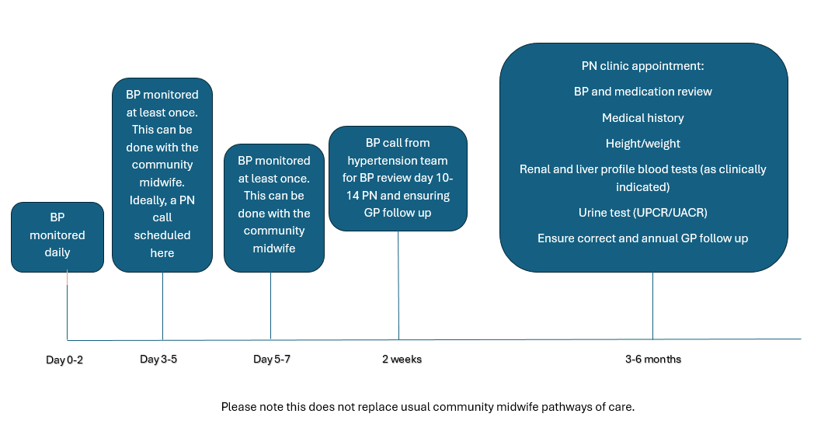
Example postnatal appointment schedule for Specialist Hypertension Clinics

- All patients that fit the postnatal criteria for the Specialist Hypertension Clinic will be given the Specialist Hypertension Clinic contact numbers on discharge. A call would be scheduled by the hypertension team for day 3-5 and day 10-14 postnatal to review BP and medication, before discharge to the GP for ongoing management of hypertension.

- At Community Midwife visits, the Community Midwife to liaise with the Specialist Hypertension Clinic if BP raised/medication needs titrating at home visits

- Automated BP machines only should be used.

Sources of Support

APEC- Downloadable patient information on pre-eclampsia - Action on Pre-eclampsia (action-on-pre-eclampsia.org.uk)

SBL Version 3- PRN00614-Saving-babies-lives-version-three-a-care-bundle-for-reducing-perinatal-mortality.pdf (england.nhs.uk)

NIHR Visuals- pregnancy-infographic-RGB-2 (action-on-pre-eclampsia.org.uk)

Preeclampsia Foundation patient_information_sheet_02.20.20_FINAL.pdf (preeclampsia.org)

NICE Recommendations | Hypertension in pregnancy: diagnosis and management | Guidance | NICE

NHS England Recommendations for digital blood pressure monitoring in maternity services

Saving Babies Lives Version 3 NHS England » Saving babies’ lives: version 3

NICE Scenario: Postpartum follow-up | Management | Hypertension in pregnancy | CKS | NICE

MBRACE MBRRACE-UK: Mothers and Babies: Reducing Risk through Audits and Confidential Enquiries across the UK | MBRRACE-UK | NPEU (ox.ac.uk)

Ockenden Report OCKENDEN REPORT - FINAL (ockendenmaternityreview.org.uk)

Better Births national-maternity-review-report.pdf (england.nhs.uk)

GMEC-Gestational-hypertension-non-severe-pre-eclampsia-and-chronic-hypertension-management-in-pregnant-women-g-1.pdf (england.nhs.uk)

GMEC- Chronic Kidney Disorders in Pregnancy Guideline

Research studies supporting home BP monitoring

SNAP-HT series of trials including Randomized Controlled trial (Cairns 2014, 2017, Cairns et al 2018, Cairns et al 2020, Kitt et al 2020)

POP-HT RCT (Kitt et al 2023) evaluate whether Physician-optimized self management of PN HTN is associated with lower BP than usual outpatient care during the first 9 months postpartum.

Appendix 1: NIHR Visuals

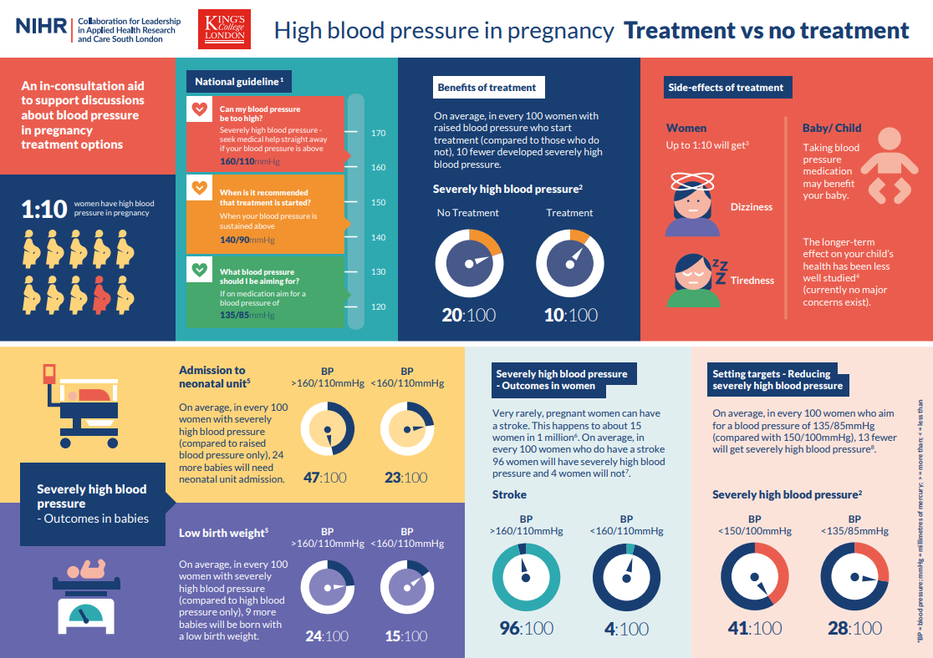

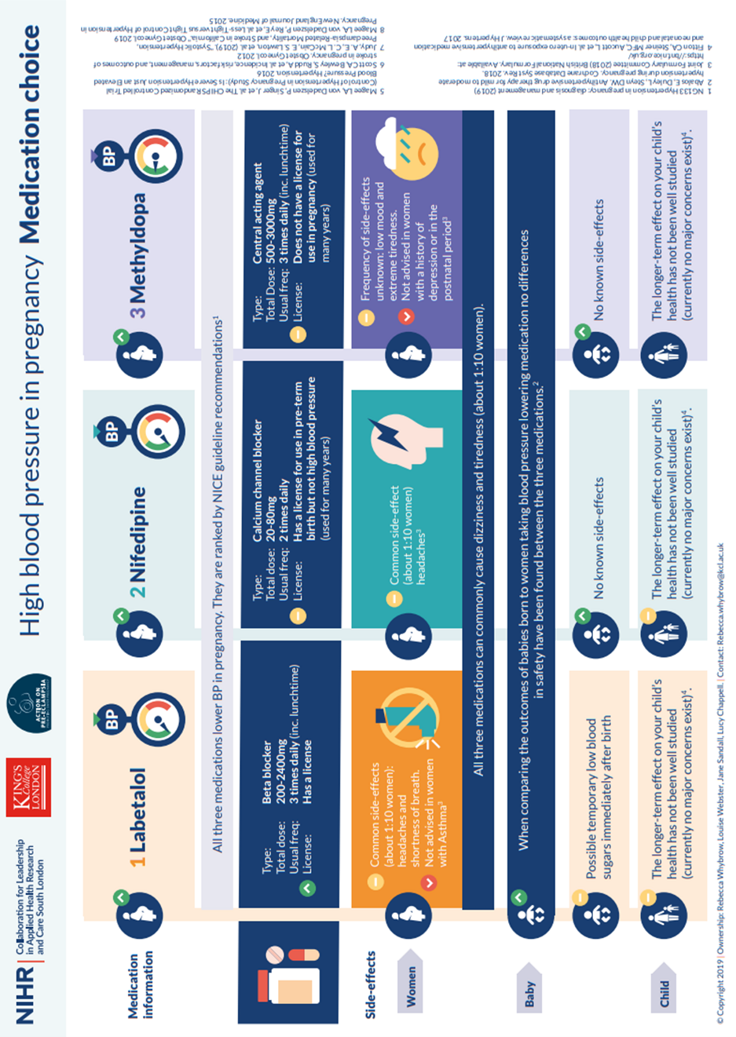

Appendix 2: Contraception

Greater Manchester and Eastern Cheshire | Sexual and Reproductive Health team at The Hathersage Centre on telephone no. 0161 701 1555  Alternatively, patients can identify their nearest clinic using the following link  https://mft.nhs.uk/mri/services/northern-sexual-health-service/
Cheshire and Merseyside | Specialist contraceptive advice can be obtained through Axess sexual health clinic (0300 323 1300).  Patients with a Liverpool GP can also self-refer to the PCN hub (clpcn.co.uk). Alternatively, patients can identify their nearest clinic using the following link https://www.axess.clinic/find-service/
Lancashire and South Cumbria | Patients can identify their nearest clinic using the following link https://lancashiresexualhealth.nhs.uk/find-nearest-centre/

Appendix 3: GP letter

Example GP letter TO BE SENT by the specialist hypertension CLINIC FOR PATIENTS ON ANTIHYPERTENSIVE MEDICATION.
